1. Computers make extensive use of the binary number system.
   1. In an 8-bit computer system, explain how to determine how many different decimal values can be represented. [2]
   2. When voltage changes in a circuit it often takes time to settle to a constant level as shown in the graph below:

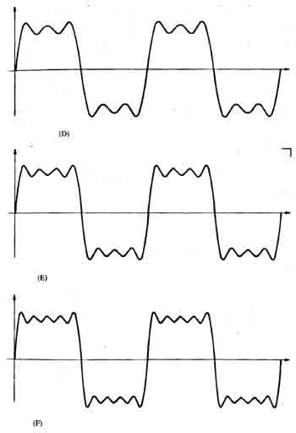

Explain why, in a computer system using binary, this effect is not an issue. [2]

1. A company runs a website where users can upload videos about sport. Users register from all over the world.
   1. The database storing the videos has grown to 2,407,117,015 bytes.   
        
      What is this value expressed in GB, rounded to 1 decimal place? [2]

* 1. The database is expected to grow in the next year to 1030 GB. A new hard disk to store the database is required.  
       
     Show that a 1 TiB hard disk would be able to store a database of this size. [2]
  2. The database uses Unicode character encoding to store details about the videos.  
       
     Describe one reason for this choice. [1]

3. The 7-bit ASCII representations of the digits 0-9 are 011 0000 to 011 1001.

(a) What is the ASCII representation of the number 3? [1]

(b) Convert this representation to denary. [1]

(c) The 7-bit ASCII representations of the letters A – Z are 100 0001 to 101 1010.

Represent the word BEAD in binary in a 32 bit byte. [3]

[Total 14 Marks]